CHAPTER 13
THE CAPITAL ASSET PRICING MODEL

Objectives
- Explain the theory behind the CAPM.
- Explain how to use the CAPM to establish benchmarks for measuring the performance of investment portfolios.
- Explain how to infer from the CAPM the correct risk-adjusted discount rate to use in discounted-cash-flow valuation models.
- Explain the APT and its relationship to the CAPM.

Outline
13.1 The Capital Asset Pricing Model in Brief
13.2 Determinants of the Risk Premium on the Market Portfolio
13.3 Beta and Risk Premiums on Individual Securities
13.4 Using the CAPM in Portfolio Selection
13.5 Valuation and Regulating Rates of Return
13.6 Extensions, Modifications, and Alternatives to the CAPM

Summary
- The CAPM has three main implications:
- In equilibrium, everyone’s relative holding of risky assets are the same as in the market portfolio.
- The size of the risk-premium of the market portfolio is determined by the risk-aversion of investors.
- The risk premium on any asset is equal to its beta times the risk premium on the market portfolio.
- Whether or not the CAPM is strictly true, it provides a rationale for a very simple passive portfolio strategy:
- Diversify your holdings of risky assets in the proportions of the market portfolio, and
- Mix this portfolio with the risk-free asset to achieve a desired risk-reward combination.
- The CAPM is used in portfolio management primarily in two ways:
- To establish a logical and convenient starting point in asset allocation and security selection
- To establish a benchmark for evaluating portfolio management ability on a risk-adjusted basis.
- In corporate finance the CAPM is used to determine the appropriate risk-adjusted discount rate in valuation models of the firm and in capital budgeting decisions. The CAPM is also used to establish a “fair” rate of return on invested capital for regulated firms and in cost-plus pricing.
- Today few financial scholars consider the CAPM in its simplest form to be an accurate model for explaining or predicting risk premiums on risky assets. However, modified versions of the model are still a central feature of the theory and practice of finance.
- The APT gives a rationale for the expected return-beta relationship that relies on the condition that there be no arbitrage profit opportunities; the CAPM requires that investors be portfolio optimizers. The APT and CAPM are not incompatible; rather, they complement each other.

Solutions to Problems at End of Chapter

Composition of the Market Portfolio
- Capital markets in Flatland exhibit trade in four securities, the stocks X, Y and Z, and a riskless government security. Evaluated at current prices in US dollars, the total market values of these assets are, respectively, $24 billion, $36 billion, $24 billion and $16 billion.
- Determine the relative proportions of each asset in the market portfolio.
- If one trader with a $100,000 portfolio holds $40,000 in the riskless security, $15,000 in X, $12,000 in Y, and $33,000 in Z, determine the holdings of the three risky assets of a second trader who invests $20, 000 of a $200, 000 portfolio in the riskless security.

SOLUTION:
The total value of all assets in the economy is 100 billion dollars.
- The proportions of each asset relative to the value of all assets are, respectively, .24 (X), .36 (Y),
- .24 (Z) and .16 (riskless bond.) The proportions of each risky asset to the total value of all risky assets are, respectively, (2/7) (X), (3/7) (Y) and (2/7) (Z).
- . Ignore the question as it appears in the First Edition of the textbook. Instead, the question should be: If an investor has $100,000 with $30,000 invested in the riskless asset, how much is invested in securities X, Y, and Z? The answer to this question is $20,000 in X and Z, and $30,000 in Y.

Implications of CAPM
- The riskless rate of interest is .06 per year, and the expected rate of return on the market portfolio is .15 per year.
- According to the CAPM, what is the efficient way for an investor to achieve an expected rate of return of .10 per year?
- If the standard deviation of the rate of return on the market portfolio is .20, what is the standard deviation on the above portfolio?
- Draw the CML and locate the foregoing portfolio on the same graph.
- Draw the SML and locate the foregoing portfolio on the same graph.
- Estimate the value of a stock with an expected dividend per share of $5 this coming year, an expected dividend growth rate of 4% per year forever, and a beta of .8. If its market price is less than the value you have estimated, i.e., if it is under-priced, what is true of its mean rate of return?

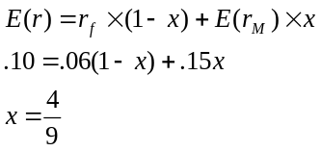SOLUTION:
a.
So one would hold a portfolio that is 4/9 invested in the market portfolio and 5/9 in the riskless asset.
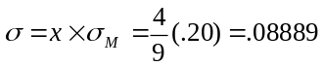b.

c. The formula for the CML is
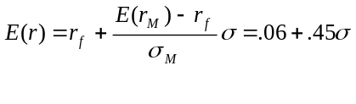
- 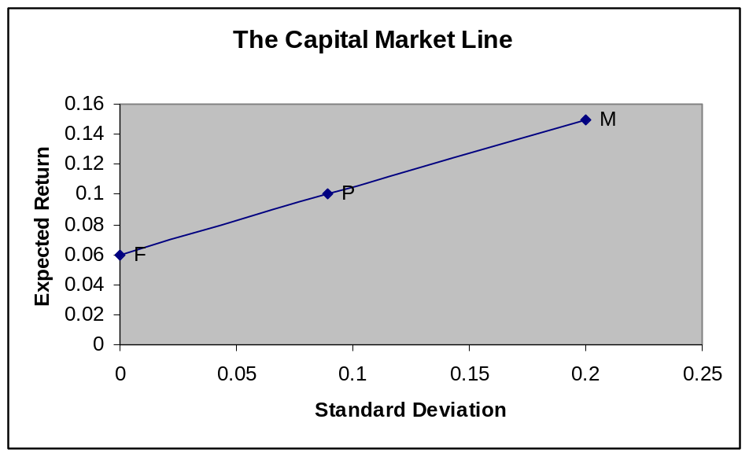The formula for the SML is
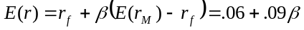
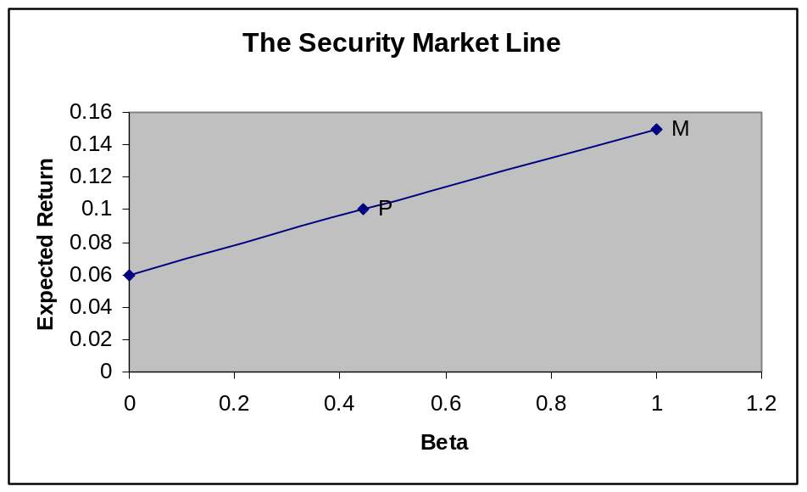
- 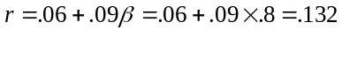Use constant growth rate DDM and find r using the SML relation

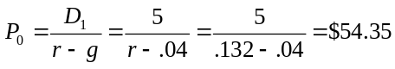
If the market price of the stock is less than this, then its expected return is higher than the 13.2% required rate.

If the CAPM is valid, which of the following situations is possible? Explain. Consider each situation independently.

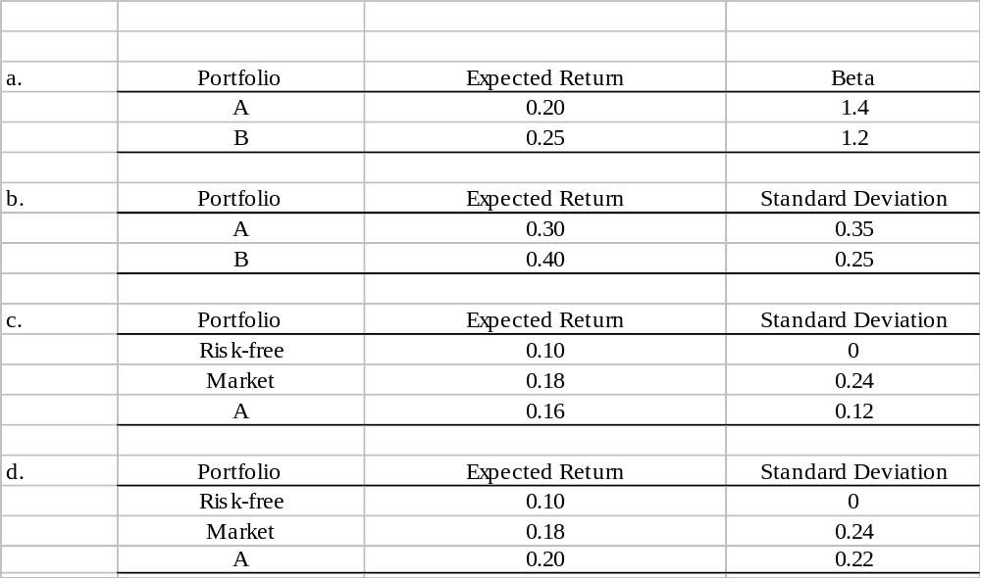

SOLUTION:
- Impossible. Since the risk premium on the market portfolio is positive, a security with a higher beta must have a higher expected return.
- Possible. Since portfolios A & B are not necessarily efficient, A can have a higher standard deviation and a lower expected return than B.
- Impossible. Portfolio A lies above the CML, implying that the CML is not efficient. If the standard deviation of A is .12, then according to the CML its expected return cannot be greater than .14.
- Impossible. Portfolio A has a lower standard deviation and a higher mean return than the market portfolio, implying that the market portfolio is not efficient.

If the Treasury bill rate is currently 4% and the expected return to the market portfolio over the same period is 12%, determine the risk premium on the market. If the standard deviation of the return on the market is .20, what is the equation of the Capital Market Line?

SOLUTION:
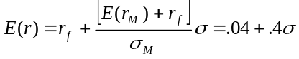 The risk premium on the market portfolio is .08. The slope of the CML is .08/.2 = .4. Thus, the equation of the CML is:

Determinants of the Market Risk Premium
Consider an economy in which the expected return on the market portfolio over a particular period is .25, the standard deviation of the return to the market portfolio over this same period is .25, and the average degree of risk aversion among traders is 3. If the government wishes to issue risk-free zero-coupon bonds with a term to maturity of one period and a face value per bond of $100,000, how much can the government expect to receive per bond?
SOLUTION:
According to the CAPM, E(r_{M}) - r_{f} = Aσ², so that r_{f} = E(r_{M}) - Aσ².
Substituting into this formula we find: r_{f} = .25 – 3 x .25² = .0625
Therefore the revenue raised by the government per bond issued is $100,000 = $94,117.65
1.0625

. Norma Swanson has invested 40% of her wealth in MGM stock and 60% in Industrial Light and Magic stock. Norma believes the returns to these stocks have a correlation of .06 and that their respective means and standard deviations are:
MGM ILM
Expected Return (%) 10 15
Standard Deviation (%) 15 25
- Determine the expected value and standard deviation of the return on Norma’s portfolio.
- Would a risk-averse investor such as Norma prefer a portfolio composed entirely of only MGM stock? Of only ILM stock? Why or why not?

SOLUTION:
- The expected return is .13, and the standard deviation is .1649.
- A risk averse investor will not want to hold a portfolio composed entirely of MGM or of ILM stock, because one can, in general, achieve the same expected return with a lower standard deviation by combining a portfolio of MGM and ILM with the risk-free asset.

Consider a portfolio exhibiting an expected return of 20% in an economy in which the riskless interest rate is 8%, the expected return to the market portfolio is thirteen percent, and the standard deviation of the return to the market portfolio is .25. Assuming this portfolio is efficient, determine:
- its beta.
- the standard deviation of its return.
- its correlation with the market return.

SOLUTION:
- Use the security market line to infer that the beta of this portfolio is 2.4:
.20 = .08 + β(.13 - .08)
β = (.20 - .08)/(.13 - .08) = .12/.05 = 2.4
- Use the capital market line to infer that the standard deviation of the yield to this portfolio is .6:
.20 = .08+ (.13 - .08) σ = .08+ .2 σ
.25
σ = .12/.2 = .6
- By definition the following relationships hold:
β = cov/σ²_{M}
ρ = cov
σ_{i} σ_{M}
where ρ denotes the correlation coefficient. We know that β = 2.4, σ_{M} = .25, and σ_{i} = .6.
So from the definition of β, we get that the cov is 2.4 x .25² = .15. Substituting this into the definition of ρ:
ρ = cov = .15 __ = 1
σ_{i} σ_{M} .6 x .25

Application of CAPM to Corporate Finance
- . The Suzuki Motor Company is contemplating issuing stock to finance investment in producing a new sports-utility vehicle, the Seppuku. Financial analysts within Suzuki forecast that this investment will have precisely the same risk as the market portfolio, where the annual return to the market portfolio is expected to be 15% and the current risk-free interest rate is 5%. The analysts further believe that the expected return to the Seppuku project will be 20% annually. Derive the maximal beta value that would induce Suzuki to issue the stock.

SOLUTION:
The project would be on the borderline if its required return were 20% per year. Since the risk-free rate is 5% and the risk premium on the market portfolio is 10%, the required return would be 20% if the beta were 1.5.

- . Roobel and Associates, a firm of financial analysts specializing in Russian financial markets, forecasts that the stock of the Yablonsky Toy Company will be worth 1,000 roubles per share one year from today. If the riskless interest rate on Russian government securities is 10% and the expected return to the market portfolio is 18% determine how much you would pay for a share of Yablonsky stock today if:
- the beta of Yablonsky is 3.
- the beta of Yablonsky is 0.5.

SOLUTION:
Use the security market line in each case to determine a required rate of return, then infer the current price from the forecasted price of 1,000 roubles and the required rate of return you have determined.
- If beta is 3, the required return is .10+ 3x.08 = .34. You would pay 1,000/1.34 = 746.27 roubles;
- If beta is .5, the required return is .10+ .5x.08 = .14. You would pay 1,000/1.14 = 877.19 roubles.

Application of CAPM to Portfolio Management
10. Suppose that the stock of the new cologne manufacturer, Eau de Rodman, Inc., has been forecast to have a return with standard deviation .30 and a correlation with the market portfolio of .9. If the standard deviation of the yield on the market is .20, determine the relative holdings of the market portfolio and Eau de Rodman stock to form a portfolio with a beta of 1.8.

SOLUTION: By definition:
β = cov/σ²_{M}
ρ = cov
σ_{r} σ_{M}
Therefore, β = ρ σ_{r}/σ_{M}. The beta of Rodman stock is therefore .9x.3/.2 = 1.35.
The beta of a portfolio is a weighted average of the betas of the component securities. Let A be a fraction of the portfolio invested in Rodman stock to produce a beta of 1.8. Then we have:
1.35A + (1-A) = 1.8
.35A = .8
A = 2.286
So the portfolio would have to have 228.6% invested in Rodman stock and a short position in the market portfolio equal to 128.6%.

- The current price of a share of stock in the Vo Giap Clothing Company of Vietnam is 50 dong and its expected yield over the year is 14%. The market risk premium in Vietnam is 8% and the riskless interest rate 6%. What would happen to the stock’s current price if its expected future payout remains constant while the covariance of its rate of return with the market portfolio falls by 50%?

SOLUTION:
Deduce that the expected future price of a share of Vo Giap is 57 dong, so that a reduction in this stock’s beta of 50% implies, by the security market relation, that the required yield on Vo Giap is now 10%, so that its current share price rises by 3.64% to a new value of 51.82 dong.

- Suppose that you believe that the price of a share of IBM stock a year from today will be equal to the sum of the price of a share of General Motors stock plus the price of a share of Exxon, and further you believe that the price of a share of IBM stock in one year will be $100 whereas the price of a share of General Motors today is $30. If the annualized yield on 91-day T-bills (the riskless rate you use) is 5%, the expected yield on the market is 15%, the variance of the market portfolio is 1, and the beta of IBM is 2, what price would you be willing to pay for one share of Exxon stock today?

SOLUTION:
Expected return = .05 + 2(.15 − .05) = 25%; (100 − x)/x = .25 → x = $80
Deduce that the current price of a share of IBM stock is $80, so that the upper bound on the price of a share of Exxon is ($80 − $30 = $50).

- Ascertain whether the following quotation is true or false, and state why:
“When arbitrage is absent from financial markets, and investors are each concerned with only the risk and return to their portfolios, then each investor can eliminate all the riskiness of his investments through diversification, and as a consequence the expected yield on each available asset will depend only on the covariance of its yield with the covariance of the yield on the diversified portfolio of risky assets each investor holds.”

SOLUTION:
False. You cannot eliminate all risk through diversification, only the unsystematic risk.

Application of CAPM to Measuring Portfolio Performance
- During the most recent 5-year period, the Pizzaro mutual fund earned an average annualized rate of return of 12% and had an annualized standard deviation of 30%. The average risk-free rate was 5% per year. The average rate of return in the market index over that same period was 10% per year and the standard deviation was 20%. How well did Pizzaro perform on a risk-adjusted basis?

SOLUTION:
Compute the ratio of average excess return to standard deviation for Pizzaro and compare it to that of the market portfolio:
Pizzaro risk-adjusted performance ratio = (.12-.05)/.30 = .233
Market portfolio risk-adjusted performance ratio = (.1-.05)/.2 = .250
So, on a risk-adjusted basis, Pizzaro did worse than the market index.

Challenge Problem

CAPM with only 2 Risky Assets
- There are only two risky assets in the economy: stocks and real estate and their relative supplies are 50% stocks and 50% real estate. Thus, the market portfolio will be half stocks and half real estate. The standard deviations are .20 for stocks, .20 for real estate, and the correlation between them is 0. The coefficient of relative risk aversion of the average market participant (A) is 3. r_{f} is .08 per year.
- According to the CAPM what must be the equilibrium risk premium on the market portfolio, on stocks, and on real estate?
- Draw the Capital Market Line. What is its slope? Where is the point representing stocks located relative to the CML?
- Draw the SML. What is its formula? Where is the point representing stocks located relative to the SML?

SOLUTION:
- The market portfolio consists of half stocks and half real estate. It has a standard deviation of .1414, computed as follows:
σ²_{M} = w²σ²_{s} + (1-w)² σ²_{r}+ 2 w(1-w) cov_{s,r}
σ²_{M} = 2 x (1/2)² .2² = .02
σ_{M} = .1414
The equilibrium risk premium on the market portfolio is E(r_{M})-r_{f} = Aσ²_{M} = 3x.02 = .06.
The market portfolio’s expected rate of return is also a weighted average of the expected rates of return on stocks and real estate, where the weights are each 1/2. Stocks and real estate must have the same risk premium because they have the same standard deviation and correlation with the market. Therefore the risk premium on stocks and real estate must be .06, the same as the market portfolio’s risk premium.
- The slope of the CML is .06/.1414 = .424. The point representing stocks is M, it is to the right of the CML.

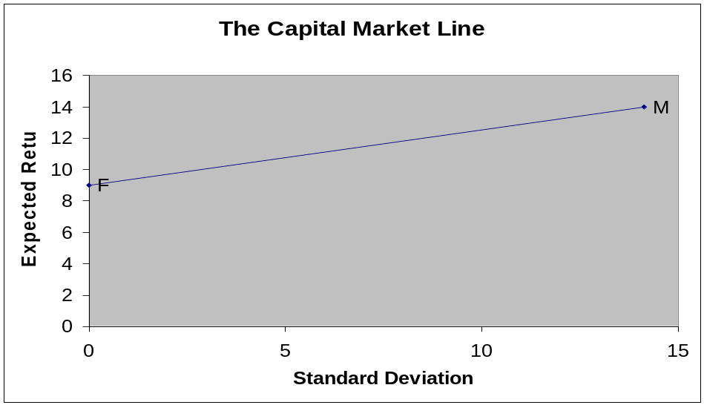c. The slope of the SML is .06, and the point representing stocks is M, it is on the SML, corresponding to Beta equaling to 1.

The formula is: E(r) = r_{f} + β(E(r_{M}) –r_{f}

